COMP 0560: Artificial Intelligence I
Final Exam
Fall 1999

Name_____________________________________

There is a total of 135 points. Your grade on this exam will be determined as follows:

Your_Grade = Exam_Score/135

Chapter 1: Introduction to AI

- [6pts] Name two expert systems that were developed during the period between 1969-1979.

- [4pts] What is Artificial Intelligence?

COMP 0560: Artificial Intelligence I
Final Exam
Fall 1999

Chapter 2: Agents

- [5pts] What is a percept sequence?

- [4pts] What is an agent program?

- [6pts] List and provide an example of three types of agents discuss in this course.

COMP 0560: Artificial Intelligence I
Final Exam
Fall 1999

Chapter 3 & 4: Uninformed & Informed Search

- [12pts] Using the Figure below, what order will the nodes be expanded using (a) iterative deepening, (b) beam search [beam size = 2], (c) A* and (d) IDA*? The numbers associated with each node is the f(n) value.

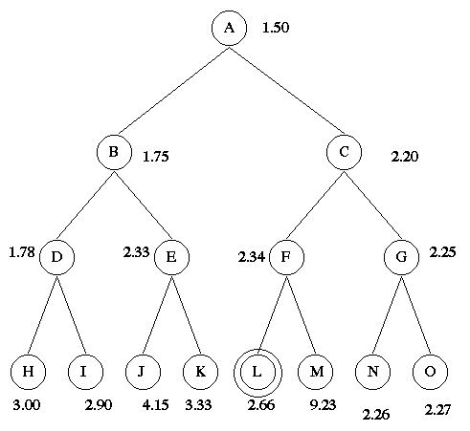

COMP 0560: Artificial Intelligence I
Final Exam
Fall 1999

- [12pts] The puzzle below consists of 4 black tiles, 4 white tiles, and 1 empty space. A tile can move into the empty space with a cost of 1. A tile can jump over 1 or 2 tiles into the empty space with a cost equal to the number of tiles jumped. Shown below are the start and goal states. The position of the empty space is not a concern (in the goal state).

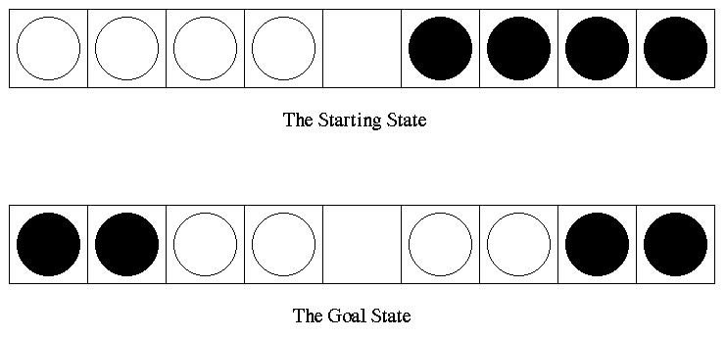

Given the problem, do the following.

- Formulate the problem as an uninformed search problem.

- Of the uninformed search methods presented in class, which would be the most appropriate to use?

- A* and IDA* are successful search algorithms; however, they both have at least one disadvantage associated with them. List one problem that a user may encounter when using a) A* search and b) IDA* search. How can one get around these problems?

COMP 0560: Artificial Intelligence I
Final Exam
Fall 1999

- [10pts] Given the search tree below use A* to learn h(n). Be sure to show all of your work.

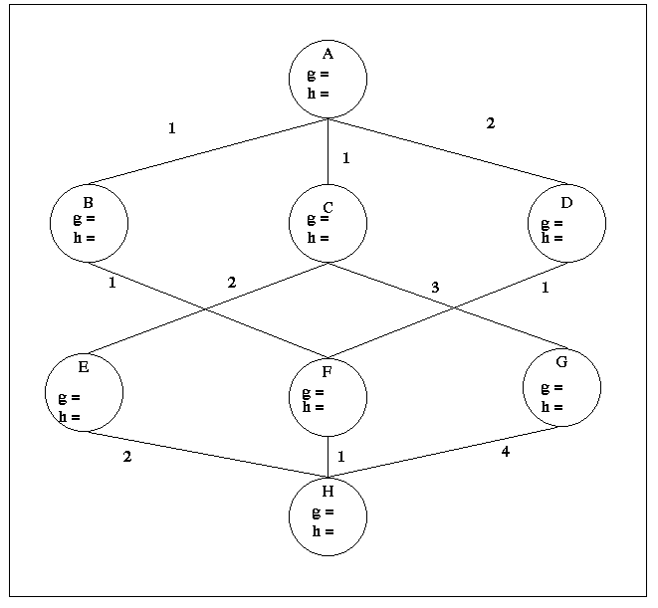

COMP 0560: Artificial Intelligence I
Final Exam
Fall 1999

Chapter 5: Game Playing

- [10pts] Show what MAX’s best first move would be using Alpha-Beta pruning. Make sure that you identify which edges are to alpha/beta pruned.

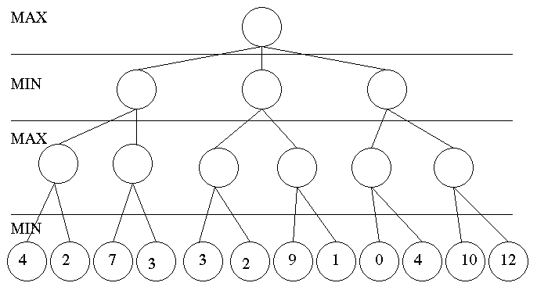

- [5pts] Given the game tree above, are the number of leaf nodes removed by an alpha-prune the same as the number of leaf nodes removed as a result of a beta-prune? If not, provide a general rule of thumb for determining which type of pruning is more desirable. Does your rule of thumb hold up under all circumstances?

COMP 0560: Artificial Intelligence I
Final Exam
Fall 1999

Chapters 6,7,9: Propositional & First Order Logic

- [10pts] Convert the following sentences into conjunctive normal form.

- ¬((¬A ∧ C) ∨ (B ∧ C)) ⇒ ((¬A ∧ ¬D) ∨ (B ∧ ¬D))

- ∀x [Q(x) ] ⇒ ∃x [∀z[P(x,z)] ∨ ∀z [W(x,z)]]

COMP 0560: Artificial Intelligence I
Final Exam
Fall 1999

- [15pts] Convert the following sentences into first order logic and use resolution refutation along with Green’s theorem to answer the question: “Who is a millionaire?”.

All tall and athletic people are marketable. Those who play basketball are athletic. Jeff is tall and he plays basketball too. Marketable people are millionaires. Jill is athletic.

COMP 0560: Artificial Intelligence I
Final Exam
Fall 1999
.

Chapter 18: Learning from Observations

- [4pts] List the 4 conceptual components of a learning agent.

- [10pts] Given the following training set compute the entropy and the gain for attributes A, B, and C. Of the three attributes which should be the root of the induction tree (Show your work)?

A | B | C | Desired Output
- | + | + | +
+ | + | - | -
+ | - | + | -
- | - | + | +
+ | + | + | -

COMP 0560: Artificial Intelligence I
Final Exam
Fall 1999

- [10pts] Use candidate elimination to find the most specific and the most general hypotheses using the data set of problem 14 (show your work).

COMP 0560: Artificial Intelligence I
Final Exam
Fall 1999

Evolutionary Computation

- [12pts] Describe the difference between generational, steady-state, (μ+λ), and (μ,λ) reproduction.

COMP 0560: Artificial Intelligence I
Final Exam
Fall 1999

COMP 0560: Artificial Intelligence I
Final Exam
Fall 1999

COMP 0560: Artificial Intelligence I
Final Exam
Fall 1999

